3.4 Differentiability Worksheet
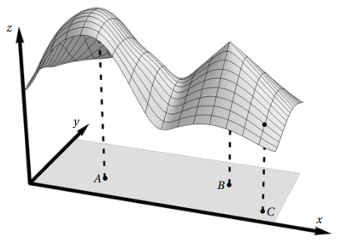
- Consider the function whose graph is shown at the right. Let A and B be points in corresponding to two “peaks” of the graph, and C be the point in corresponding to the dot on the graph. For each part, circle the answer that is the most consistent with the picture.

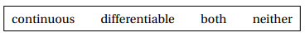
- At the point A, the function g is:


- At the point B, the function g is:

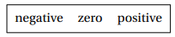
- At the point C, the function is:

- Show that is differentiable at .

- Show that is differentiable at

- Consider the function .
- Confirm that the function is differentiable at the point .

- Confirm that the function is continuous at the point .

- Consider the function .
- Confirm that the function is differentiable at .

- Confirm that the function is continuous at the point .

